

**The Music Player**

**13006107 Introduction to Computers and Programming**

**Software Engineering Program**

**Faculty of Engineering, KMITL**

By

64011378 Chiho Li

**Intro**

Music is a powerful tool that humans have invented and developed, music influences emotions and it is proved throughout history that emotions control most of the decisions and influence performances. As an example, whenever you're feeling great you tend to perform better than sitting in silence and it also relaxes your mind to keep yourself from overworking.

**Motivation**

I think being able to listen to music while working or just relaxing is very crucial to a healthy work environment and increased work performance. Music always keeps me calm when under stressful situations, keeps my focus in check

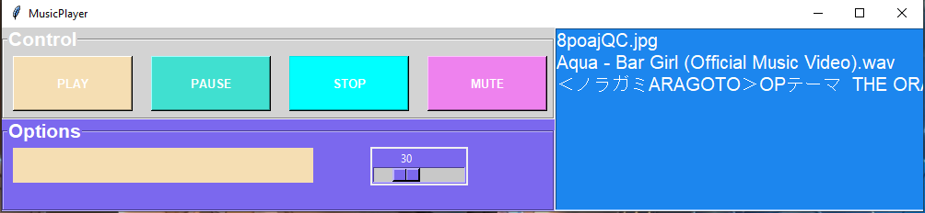

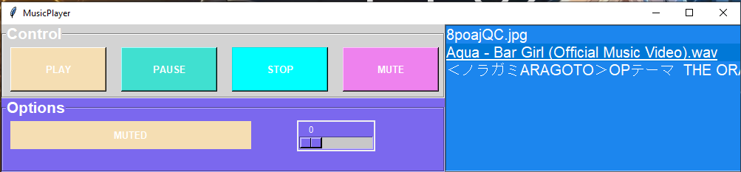

from tkinter import *

import pygame

from pygame import mixer

import os

import tkinter.messagebox

def play():

global paused

if paused:

mixer.music.unpause()

songstatus.set("Resumed")

paused = FALSE

else:

try:

stop()

holder = playlist.get(ACTIVE)

mixer.music.load(playlist.get(ACTIVE))

mixer.music.play()

songstatus.set(f"Playing: {holder}")

except:

tkinter.messagebox.showerror("File not found","Please select the file again! or wrong file type! ")

paused = FALSE

def pause():

global paused

paused = TRUE

mixer.music.pause()

songstatus.set("Paused")

def stop():

mixer.music.stop()

songstatus.set("Stopped")

muted = FALSE

def mute():

global muted

if muted:

mixer.music.set_volume(0.3)

scale.set(30)

muted = FALSE

else:

mixer.music.set_volume(0)

scale.set(0)

songstatus.set("MUTED")

muted = TRUE

def set_vol(i):

volume= float(i)/100

mixer.music.set_volume(volume)

root = Tk()

root.geometry("1000x200+200+200")

root.title("MusicPlayer")

pygame.init()

mixer.init()

songstatus = StringVar()

def close():

stop()

root.destroy()

root.protocol("WM_DELETE_WINDOW",close)

# Mainframe

frame = LabelFrame(root,text="Control",font =("Helvetica",16,"bold"),bg="lightgrey",fg="white")

frame.place(x=0,y=0,width=600,height=100)

play_button = Button(frame, width=15, height=3,font =("Helvetica",10,"bold"),text="PLAY",command=play, bg="wheat",fg="white").grid(row=0,column=0,padx=10,pady=5)

pause_button = Button(frame, width=15, height=3, text="PAUSE",command=pause,font =("Helvetica",10,"bold"), bg="turquoise", fg="white").grid(row=0,column=1,padx=10,pady=5)

stop_button = Button(frame, width=15, height=3, text="STOP",command=stop,font =("Helvetica",10,"bold"), bg="cyan", fg="white").grid(row=0,column=2,padx=10,pady=5)

unpause_button = Button(frame, width=15, height=3, text="MUTE",command=mute,font =("Helvetica",10,"bold"), bg="violet", fg="white").grid(row=0,column=3,padx=10,pady=5)

# Options frame

second_frame = LabelFrame(root,text="Options",font =("Helvetica",16,"bold"),bg="mediumslateblue",fg="white")

second_frame.place(x=0,y=100,width=600,height=100)

status = Label(second_frame,width=40, height=2,textvariable = songstatus,font =("Helvetica",10,"bold"),bg="wheat",fg="white").grid(row = 0, column = 1,padx=10,pady=5)

# volume scale

scale = Scale(root,from_=0, to=100,orient=HORIZONTAL, command=set_vol,bg="mediumslateblue",fg="white")

scale.set(30)

scale.grid(row=0,column = 1,pady = 130, padx=400)

mixer.music.set_volume(0.3)

# Playlist

playlist=Listbox(root,selectmode=SINGLE,bg="DodgerBlue2",fg="white",font=('arial',15),width=40)

playlist.grid(columnspan=5)

playlist.place(x=600,y=0,width=600,height=200)

# Directory for songs

os.chdir(r"C:\Users\User\Desktop\Playlist")

songs = os.listdir()

for i in songs:

playlist.insert(END,i)

mainloop()